Anomalous temperature and seasonality of mortality

in the United States

  - Robbie Michael Ignatius Parks

  - Department of Epidemiology and Biostatistics
  - School of Public Health
  - Faculty of Medicine
  - Imperial College London

  - Thesis submitted for fulfilment of the requirements for
  - Doctor of Philosophy (PhD)
  - August 2019

Abstract

Table of Contents
Abstract 3
List of tables 10
List of figures 11
List of equations 17
List of abbreviations 18
Copyright 20
Declaration of originality 21
Acknowledgments 22
1 Introduction 23
1.1 Rationale 23
1.2 Aims and objectives 24
1.3 Structure of the thesis 24
2 Background 25
2.1 Trends in mortality in the United States 25
2.2 Trends in temperature in the United States 26
2.3 Seasonal mortality 27
2.3.1 Excess winter mortality 27
2.3.2 Methods of analysing seasonal mortality 28
2.3.3 Determinants of seasonal mortality 29
2.4 Temperature and mortality 30
2.4.1 Effects of temperature on humans 30
2.4.2 Extreme heat and cold 31
2.4.3 Temperature-mortality association 33
2.4.4 Cause of death 33
2.4.5 Demographic determinants 35
2.4.6 Other environmental determinants 37
2.4.7 Mortality displacement 37
2.5 Modelling methodologies and computational issues 38
2.5.1 Treatment of time 38
2.5.2 Accounting for month and season in models 39
2.5.3 Treatment of space 39
2.5.4 Cohort studies 40
2.5.5 Computational considerations 40
2.6 Summary 41
3 Data sources 42
3.1 Overview 42
3.2 Cause-specific deaths and population 42
3.2.1 Objectives 42
3.2.2 Sources of mortality data 43
3.2.3 Population data 43
3.2.4 Assigning causes of death 44
3.2.5 Classifying causes of death 46
3.2.6 Age groups 49
3.2.7 Patterns and trend in mortality 49
3.3 Meteorological data 58
3.3.1 Objectives 58
3.3.2 Sources of meteorological data 58
3.3.3 Weather reanalysis data 59
3.3.4 Converting gridded meteorological data to area-weighted summaries 60
3.3.5 Creating state-level summaries 63
3.3.6 Anomalous temperature 66
3.3.7 Comparing county- with state-level anomalies 70
3.3.8 Comparison with PRISM dataset 72
3.4 Summary 74
4 National and regional seasonal dynamics of cause-specific mortality 75
4.1 Overview 75
4.2 Introduction 75
4.3 Data 78
4.4 Statistical methods 78
4.5 Results 81
4.5.1 Wavelet analysis 81
4.5.2 Centre of gravity analysis 92
4.5.3 Change in percent difference in death rates 100
4.6 Discussion 102
4.7 Summary 104
5 Statistical modelling of anomalous monthly temperature and monthly mortality 105
5.1 Overview 105
5.2 Objectives 105
5.3 Data 106
5.4 Model specification 106
5.4.1 National terms 110
5.4.2 Month terms 110
5.4.3 State terms 110
5.4.4 Interaction terms 111
5.4.5 Non-linear time trends 112
5.4.6 Temperature anomaly term 112
5.4.7 Hyperparameters on precisions of random effects 115
5.4.8 Alternative random walk structure 117
5.4.9 Inclusion of long-term norm temperature 118
5.4.10 Temperature anomaly coefficient structure 120
5.4.11 Additional extreme temperature measures 122
5.4.12 State-specific temperature model specification 124
5.5 Confounders, effect modifiers and mediators 127
5.5.1 Confounders 127
5.5.2 Effect modifiers 128
5.5.3 Mediators 129
5.6 Model fitting 130
5.7 Model evaluation 130
5.8 Excess risk and uncertainty 133
5.9 Summary 133
6 Anomalous monthly temperature and monthly injury mortality 135
6.1 Overview 135
6.2 Introduction 135
6.3 Data 136
6.4 Statistical methods 136
6.5 Results 138
6.5.1 Summary of injury deaths 138
6.5.2 Trends in injury mortality 141
6.5.3 Excess risk of injury deaths associated with temperature anomaly 143
6.5.4 Percentage change of injury deaths associated with anomalous temperature 150
6.5.5 Change in injury deaths associated with anomalous temperature 153
6.6 Discussion 155
6.7 Summary 157
7 Anomalous monthly temperature and monthly cardiorespiratory disease and cancer mortality 159
7.1 Overview 159
7.2 Introduction 159
7.3 Data 160
7.4 Statistical methods 161
7.5 Results 163
7.5.1 Summary of cardiorespiratory disease and cancer deaths 163
7.5.2 Trends in cardiorespiratory disease and cancer mortality 166
7.5.3 Excess risk of cardiorespiratory disease and cancer deaths associated with temperature anomaly 168
7.5.4 Percentage change of cardiorespiratory disease deaths associated with anomalous temperature 176
7.5.5 Change in cardiorespiratory disease deaths associated with anomalous temperature 179
7.5.6 Percentage change of sub-national cardiorespiratory disease deaths associated with anomalous temperature 181
7.6 Discussion 185
7.7 Summary 188
8 Discussion 189
8.1 Comparison with published literature 189
8.1.1 Seasonal dynamics of mortality 189
8.1.2 Anomalous monthly temperature and mortality 190
8.2 Strengths and limitations 191
8.3 Public health and policy implications 193
8.4 Future work 194
8.5 Conclusions 195
Works cited 197

List of tables
Table 1. Summary statistics by percentile for states used in the analysis. 57
Table 2. Correlation coefficients between monthly temperatures generated from mean daily and maximum or minimum daily temperatures. 65
Table 3. Characteristics of climate regions of the United States. 77
Table 4. Temperature model parameters. 108
Table 5. Temperature model priors. 109
Table 6. DIC values and run times from comparison of random walk terms. 116
Table 7. Number of model run comparisons which favoured the temperature model (Equation 4) over the temperature model with piecewise temperature anomaly term (Equation 8). 121
Table 8. Correlation coefficients between anomaly of mean daily temperature and measures of extreme anomalous temperature. 123
Table 9. Predictive validity metrics of model fit for males aged 65 to 74 years for 1980-2016 using temperature model (Equation 4). 131
Table 10. Injury groups used in the analysis with ICD-9 and ICD-10 codes. 137
Table 11. Cardiorespiratory disease and cancer groups used in the analysis with ICD-9 and ICD-10 codes. 162

List of figures
Figure 1. Tree structure of causes of death. 47
Figure 2. Number of deaths by cause, sex and age group in the contiguous United States for 1980-2016. 52
Figure 3. Number of deaths by cause, month, sex and age group in the contiguous United States for 1980-2016. 53
Figure 4. National age-standardised death rates from 1980 to 2016, by cause and month. 54
Figure 5. Cardiorespiratory disease annual age-standardised death rates in four example years at the beginning of each decade throughout the study period. 56
Figure 6. Example of method for generating county-level temperature summaries. 62
Figure 7. Map of norm temperature (°C) from 1980 to 2016, by state and by month. 64
Figure 8. Graphic representation of temperature anomaly measure used in the analysis. 67
Figure 9. Average size of temperature anomaly (°C) from 1980 to 2016, by state and month. 69
Figure 10. Average county temperature anomaly deviation from state-level anomaly (°C) from 1980 to 2016, by each state and month. 71
Figure 11. Comparison of monthly summaries of temperature from ERA-Interim against PRISM. 73
Figure 12. Climate regions of the United States. 76
Figure 13. Wavelet power spectra for national time series of all-cause death rates for 1980-2016, by age group for males. 82
Figure 14. Wavelet power spectra for national time series of all-cause death rates for 1980-2016, by age group for females. 83
Figure 15. Wavelet power spectra for national time series of cancer death rates for 1980-2016, by age group for males. 84
Figure 16. Wavelet power spectra for national time series of cancer death rates for 1980-2016, by age group for females. 85
Figure 17. Wavelet power spectra for national time series of cardiorespiratory disease death rates for 1980-2016, by age group for males. 86
Figure 18. Wavelet power spectra for national time series of cardiorespiratory disease death rates for 1980-2016, by age group for females. 87
Figure 19. Wavelet power spectra for national time series of injury death rates for 1980-2016, by age group for males. 88
Figure 20. Wavelet power spectra for national time series of injury death rates for 1980-2016, by age group for females. 89
Figure 21. Wavelet power spectra for national time series of death rates from causes other than cancers, cardiorespiratory diseases and injuries for 1980-2016, by age group for males. 90
Figure 22. Wavelet power spectra for national time series of death rates from causes other than cancers, cardiorespiratory diseases and injuries for 1980-2016, by age group for females. 91
Figure 23. Mean timing of maximum and minimum all-cause and cause-specific mortality at the national level, by sex and age group for 1980-2016. 94
Figure 24. Mean timing of maximum all-cause mortality for 1980-2016, by climate region and age group for males. 95
Figure 25. Mean timing of minimum all-cause mortality for 1980-2016, by climate region and age group for males. 96
Figure 26. Mean timing of maximum all-cause mortality for 1980-2016, by climate region and age group for females. 97
Figure 27. Mean timing of minimum all-cause mortality for 1980-2016, by climate region and age group for females. 98
Figure 28. The relationship between percent difference in all-cause death rates and temperature difference (°C) between months with maximum and minimum mortality across climate regions, by sex and age group in 2016. 99
Figure 29. National percent difference in death rates between the maximum and minimum mortality months for all-cause and cause-specific mortality in 2016 versus 1980, by sex and age group. 101
Figure 30. Relationship between monthly temperature anomaly (°C) and apparent temperature anomaly (°C), across all months from 1980 to 2016, by state. 114
Figure 31. Relationship between temperature parameters from temperature model (Equation 4) and temperature parameters from temperature model with long-term norm temperature included (Equation 7). 119
Figure 32. Comparison of additional annual cardiorespiratory disease deaths for the 2016 population in year in which each month was +1°C compared with 1980-2009 norm temperatures. 126
Figure 33. DAG describing the potential confounding of air pollution on a study of tempearture and mortality. 128
Figure 34. Raw cardiorespiratory monthly disease death rates fit against fitted cardiorespiratory death rates for males aged 65 to 74 years, across all months from 1980-2016. 132
Figure 35. Number of injury deaths, by type of unintentional (transport, falls, drownings, and other) and intentional (assault and suicide) injury, sex and age group in the contiguous United States for 1980-2016 139
Figure 36. Number of deaths by type of injury, month, sex and age group in the contiguous United States for 1980-2016. 140
Figure 37. National age-standardised death rates from 1980 to 2016, by type of injury, month and sex. 142
Figure 38. Excess relative risk in transport death rates in year in which each month was +1°C compared with 1980-2009 norm temperatures by month, sex and age group. 144
Figure 39. Excess relative risk in fall death rates in year in which each month was +1°C compared with 1980-2009 norm temperatures by month, sex and age group. 145
Figure 40. Excess relative risk in drowning death rates in year in which each month was +1°C compared with 1980-2009 norm temperatures by month, sex and age group. 146
Figure 41. Excess relative risk in assault death rates in year in which each month was +1°C compared with 1980-2009 norm temperatures by month, sex and age group. 147
Figure 42. Excess relative risk in suicide death rates in year in which each month was +1°C compared with 1980-2009 norm temperatures by month, sex and age group. 148
Figure 43. Excess relative risk in other unintentional injury death rates in year in which each month was +1°C compared with 1980-2009 norm temperatures by month, sex and age group. 149
Figure 44. Percent change in death rates in year in which each month was +1°C compared with 1980-2009 norm temperatures by type of injury, sex and age group summarised across months. 151
Figure 45. Percent change in death rates in year in which each month was +1°C compared with 1980-2009 norm temperatures by type of injury, sex and month summarised across ages. 152
Figure 46. Additional annual injury deaths for the 2016 US population in year in which each month was +1°C warmer compared with 1980-2009 norm temperatures. 154
Figure 47. Number of deaths by cardiorespiratory disease and cancer, sex and age group in the contiguous United States for 1980-2016. 164
Figure 48. Number of deaths by cardiorespiratory disease and cancer, month, sex and age group in the contiguous United States for 1980-2016. 165
Figure 49. National age-standardised death rates from 1980 to 2016, by cardiorespiratory disease and cancer, month and sex. 167
Figure 50. Excess relative risk in IHD death rates in year in which each month was +1°C compared with 1980-2009 norm temperatures by month, sex and age group. 169
Figure 51. Excess relative risk in cerebrovascular disease death rates in year in which each month was +1°C compared with 1980-2009 norm temperatures by month, sex and age group. 170
Figure 52. Excess relative risk in other cardiovascular disease death rates in year in which each month was +1°C compared with 1980-2009 norm temperatures by month, sex and age group. 171
Figure 53. Excess relative risk in COPD death rates in year in which each month was +1°C compared with 1980-2009 norm temperatures by month, sex and age group. 172
Figure 54. Excess relative risk in respiratory infection death rates in year in which each month was +1°C compared with 1980-2009 norm temperatures by month, sex and age group. 173
Figure 55. Excess relative risk in other respiratory disease death rates in year in which each month was +1°C compared with 1980-2009 norm temperatures by month, sex and age group. 174
Figure 56. Excess relative risk in cancer death rates in year in which each month was +1°C compared with 1980-2009 norm temperatures by month, sex and age group. 175
Figure 57. Percent change in death rates in year in which each month was +1°C compared with 1980-2009 norm temperatures by cardiorespiratory disease, sex and age group summarised across months. 177
Figure 58. Percent change in death rates in year in which each month was +1°C compared with 1980-2009 norm temperatures by cardiorespiratory disease, sex and month summarised across age. 178
Figure 59. Additional annual cardiorespiratory disease deaths for the 2016 US population in year in which each month was +1°C compared with 1980-2009 norm temperatures. 180
Figure 60. Percent change in cardiorespiratory disease death rates for males in year in which each month was +1°C compared with 1980-2009 norm temperatures by state and month summarised across age groups. 183
Figure 61. Percent change in cardiorespiratory disease death rates for females in year in which each month was +1°C compared with 1980-2009 norm temperatures by state and month summarised across age groups. 184

List of equations
Equation 1. Death rate calculation formula. 43
Equation 2. Circular mean calculation. 80
Equation 3. Temperature model Poisson distribution. 106
Equation 4. Temperature model. 107
Equation 5. Apparent temperature ($Tapp)$ calculation, where $Ta$ is air temperature and $Td$ is dew-point temperature. 113
Equation 6. Temperature model with alternative random walk structure. 117
Equation 7. Temperature model with long-term norm temperature term. 118
Equation 8. Temperature model with piecewise temperature anomaly term. 120
Equation 9. Temperature model with state-specific anomaly coefficients. 124
Equation 10. Relative risk calculation using anomalous temperature parameters from temperature model (Equation 4). 133

List of abbreviations
3DVAR | Three-dimensional variational data assimilation
4DVAR | Four-dimensional variational data assimilation
ACME | Automated Classification of Medical Entities
BUGS | Bayesian inference Using Gibbs Sampling
CAR | Conditional autoregressive
CDC | Centers for Disease Control and Prevention
CKDu | Chronic kidney disease of unknown aetiology
COPD | Chronic obstructive pulmonary disease
CI | Confidence interval
CrI | Credible interval
DAG | Directed Acyclic Graph
DHS | Department of Homeland Security
DIC | Deviation information criterion
ECMWF | European Centre for Medium-Range Weather Forecasts
EPA | Environmental Protection Agency
ERA | ECMWF re-analysis
GMRF | Gaussian Markov random field
ICD | International Classification of Diseases
IHD | Ischaemic heart disease
INLA | Integrated nested Laplace approximation
IPCC | Intergovernmental Panel on Climate Change
JAGS | Just another Gibbs sampler
MCMC | Markov Chain Monte Carlo
NCAR | National Center for Atmospheric Research
NCEP | National Centers for Environmental Prediction
NCHS | National Center for Health Statistics
NOAA | National Oceanic and Atmospheric Administration
NUTS | No U-Turn Sampler
PM_{2.5} | Particulate matter with diameter less than 2.5 micrometres
PM₁₀ | Particulate matter with diameter less than 10 micrometres
PRISM | Parameter-elevation Regression on Independent Slopes Model
SDG | Sustainable Development Goal
TMB | Template Model Builder
UN | United Nations
UNFCCC | United Nations Framework Convention on Climate Change
UNISDR | United Nations International Strategy for Disaster Reduction
VR | Vital registration
WHO | World Health Organization
WMO | World Meteorological Organization

Copyright
The copyright of this thesis rests with the author and is made available under a Creative Commons Attribution Non-Commercial no Derivatives licence. Researchers are free to copy, distribute or transmit the thesis on the condition that they attribute it, that they do not use it for commercial purposes and that they do not alter, transform or build upon it. For any reuse or redistribution, researchers must make clear to others the licence terms of this work.

Declaration of originality
I hereby declare that the work in this thesis is my own original research and that I have appropriately cited any work that is not my own.

Acknowledgments

Introduction

Rationale

Aims and objectives

Structure of the thesis

Background

Data sources

Cause-specific deaths and population

Objectives

Sources of mortality data

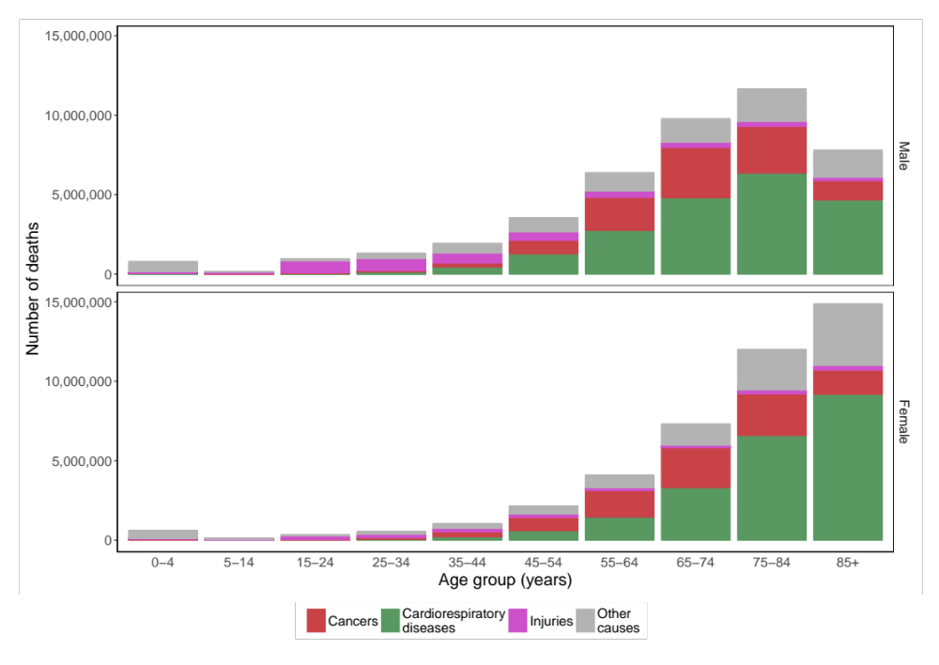
Figure 2. Number of deaths by cause, sex and age group in the contiguous United States for 1980-2016.

Climate region | Constituent states | Population (2016) | Mean annual temperature (1980-2016) (°C)
Central | Illinois, Indiana, Kentucky, Missouri, Ohio, Tennessee, West Virginia | 50,191,326 | 11.6
East North Central | Iowa, Michigan, Minnesota, Wisconsin | 24,418,738 | 8
Northeast | Connecticut, Delaware, Maine, Maryland, Massachusetts, New Hampshire, New Jersey, New York, Pennsylvania, Rhode Island, Vermont | 64,046,741 | 10.6
Northwest | Idaho, Oregon, Washington | 13,069,916 | 8.2
South | Arkansas, Kansas, Louisiana, Mississippi, Oklahoma, Texas | 45,388,414 | 18
Southeast | Alabama, Florida, Georgia, North Carolina, South Carolina, Virginia | 59,356,072 | 18.4
Southwest | Arizona, Colorado, New Mexico, Utah | 17,613,981 | 13.6
West | California, Nevada | 42,280,017 | 16.6
West North Central | Montana, Nebraska, North Dakota, South Dakota, Wyoming | 5,168,753 | 7.6
Table 3. Characteristics of climate regions of the United States.

Works cited

